## Greenparc Bleiswijk

De optimale inrichting van het electriciteitsnetwerk hangt af van de lokale context. In dit hoofdstuk beschrijven we daarom

* 1. De huidige situatie in Greenparc Bleiswijk (netwerktopologie, type afnemers, verbruiksprofielen en leveringsprofielen). Hierbij nemen we zowel elektriciteit, gas en lokale mobiliteit mee.
  2. Mogelijkheden in het voorkomen van congestie (referentie)
  3. Voorziene veranderingen als gevolg van de energietransitie (elektrificatie, uitfaseren aardgas, lokale opwek en opslag)

## Huidige situatië in Greenparc

Greenparc ligt in het noorden van Gemeente Lansingeringland in de Zuid-Holland povince. There are 6 Other bedrijvterrien within 20 Km radius from Greenparc. Greenparc is situated in the vicinity of Tennet 380kV substation. Greenparc is connected to A12 – A13 – A20 – A4. There are 26 EV Charging stations all over Bleiswijk. The New Motion in Christian Huygenstraat and Jan van den Heydenstraat are the two most utilized in the region.

The Greenparc external supply consists of gas and electricity connections. STEDIN serves Greenparc gas and electricity supply. In gemeente Lansingerland, there are 7.8 MWp of Solar Panel installed. 1814 EV cars per 100.000 Auto

Greenparc energy is served by two gas connections with total capacity flow of 12 m3 per hour. Additionally, there are 21 middenspanningsstations in the area with 400 Volt low voltage connections divided into 3x35A 3x50A cables. Only one EV charging station is available in Greenparc, that charging station is situated in the Royal Lemkes parking area and managed by Engie (with tariff of €0,375 / kWh across all Rotterdam-Den Haag regio).

With the total area reaching to 563 M2, Greenparc host 19 companies. 10 of the 19 companies in the Greenparc are sepecialised logistics companies in flowers and vegetables delivery. As a result the energy consumption in Greenparc revolve around the transportation in the heating plan and the cooling operation in several companies. Figure 1 shows the overview energy activities in Greenparc.

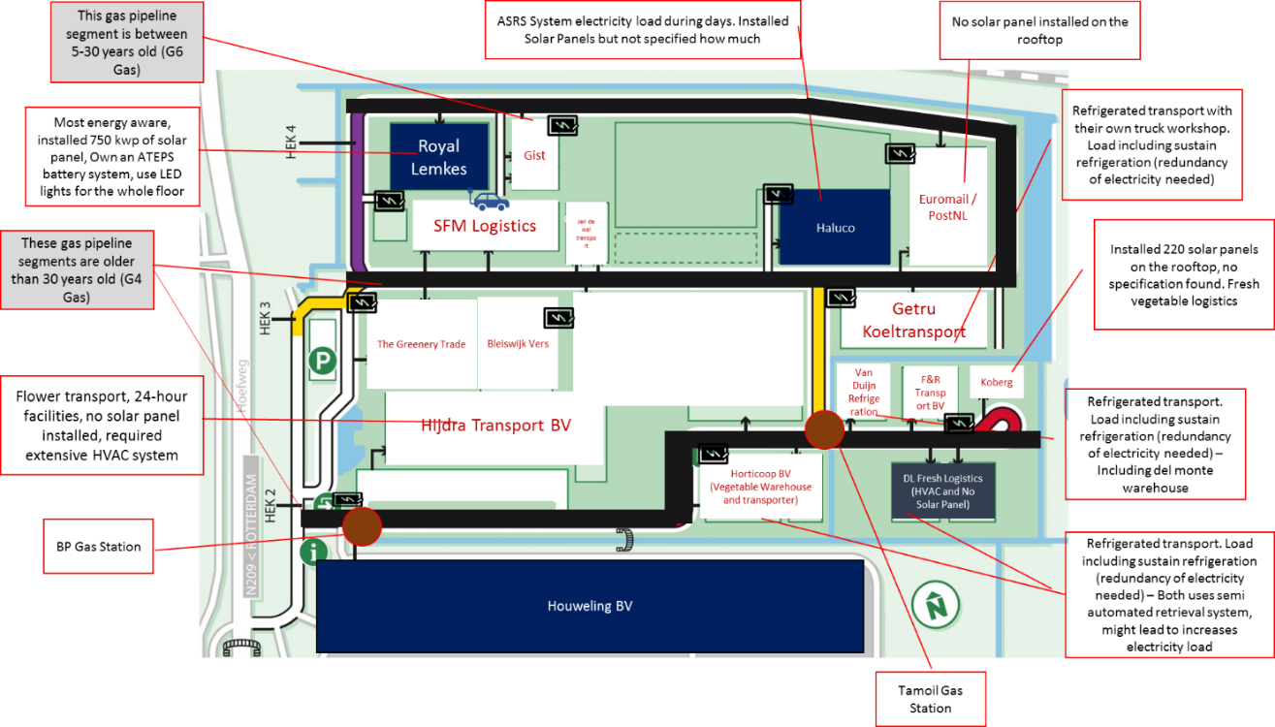

Figure Overview of Greenparc Activities

The 2665 post code smart meter just recently installed in the 2nd quarter of 2019. According to the klimatmonitor database the 2018 annual solar production in the Area is 605,555 kWh. That includes the production by Royal Lemkes and Koberg.

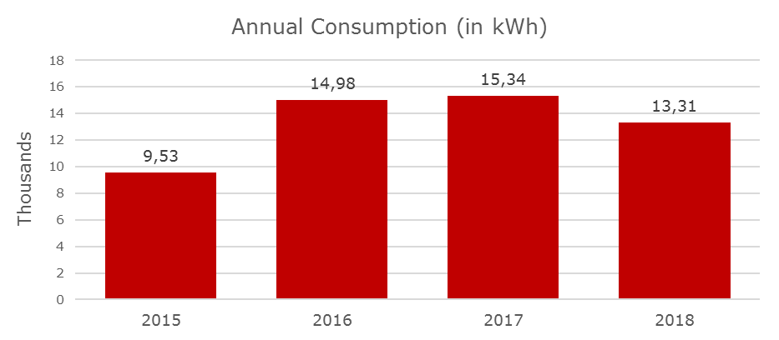

Figure Greenparc Electricity Consumption (Source: STEDIN Annual data)

Power to Heat and Power to Mobility is going to be important in Greenparc for the variable energy supply and demand since the normal demand is going to remain low in the Greenparc especially due to increasing efficiencies of the equipments in the Greenparc companies. The area especially in the south part of the Klappoderweg is subject to the gas pipe replacement by STEDIN in the near future. This give a unique opportunity to design necessary infrastructure for improving renewable energy adoption through Power-to-Heat function.

Several Demand that needs to be taken into account:

* 1. Electricity demand from the changes happen due to the transition on the mobility side from fuel to power. That means there should be a di stepwise increase changes happen. Special attention on the HVAC because there are some special logistical purpose on the park.
  2. Electricity demand from the heat pump in which the heat will be generated no more from gas connection but from the transformation of power generated by the renewable energy sources namely the solar panel installed on top of the warehouse
  3. Electriciteitopslaag is going to be the peak shaper in the demand response of the system.
  4. Water consumption is also important since there are some that handle flower logistics. Flower logistics require constant access to the water.

**We can also show the flows of energy and its cost using Sankey diagram.**

Figure Example Chart

Is it possible in the current profile of the Greenparc. The current system relies heavily on the grid connection installed in several places of Greenparc.

Additional information needed to simulate the system in Greenparc:

1. Data demand (electricity and gas) for the companies
2. Investment profile of Royal Lemkes for their ATEPS battery system to find out how much is the cost per kWh electricity stored
3. Infrastructure development also an important thing because the cabling is not meant for carrying big load of Reactive Power

## Mogelijkheden in het voorkomen van congestie (referentie)

Definitie van congestie:

Congestion can be described within the Regulation (EC) No 714/2009 (European Union, 2009) as ‘a situation in which an interconnected power system cannot accommodate all physical flows resulting from trade requested by market participants, because of a lack of capacity of relevant network element’.

1. Using current condition (Network) shows where the potential of congestion

At the moment, the system in Bleiswjik is far from being congested. Because, the renewable energy produced is concentrated in the Royal Lemkes facility and being stored in their battery system.

1. There are several case studies that we can draw the experiences from:
2. Enera Germany – In Collaboration with Elaad and Eneco (Using USEF) Residential Area
3. Nijmegen North – Liander (Using USEF) Residential and Commercial area
4. Hoog Dalem – STEDIN (Using USEF and LES by Jules Energy) Residential Area
5. Brooklyn – New York City

From here we can use the lesson to draw up some scenarios in which who the current system in Bleiswijk might be congested.

How the system can be congested. Curtailment in the current load, heat pump demand, and HVAC demand. Most of the time, the system will benefit from a closed loop heating system.

Furthermore three limits of electricity congestion that needs to be analyzed:

1. Thermal limit in the transmission line
2. Voltage limit in the transmission line
3. Stability limit within the transmission network

Additionally address the usage of USEF on looking at possible congestion in the current Greenparc system. How the market create incentives in the local community to maintain stable relationship. Using shapley value to cohesiveness in

Het marktproces in het layered energy system volgt de USEF stappen: PLAN - OPERATE - SETTLE. Dit proces is op hoofdlijnen uitgewerkt. Op basis hiervan is de toepasbaarheid van blockchain getoetst.

There is big opportunities for Greenparc to adopt EV trucks as DAF provided EV truck lines

Different contract model that can be tried in the Greenparc setting:

* Contract for Difference (Nordpool market model, implemented in the border connection between Norway and Denmark) – This contract with
* Explicit auctioning of network capacity – require new